
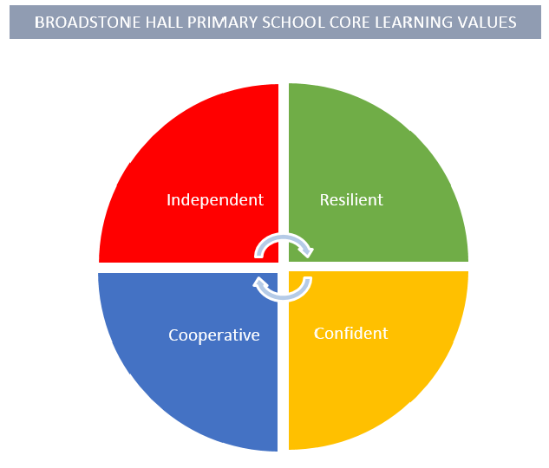

FOREST SCHOOL:
Medical/Emergency Contact Form

Course or Activity: | Forest School Y3 Broadstone Hall
Date of Course/Activity:

Participant Details
Surname:
Forename(s):
Date of Birth:
Medical Information |  | Please indicate
Does your child suffer from any illness or physical disability? If so please describe:  _______________________________________________________  _______________________________________________________  _______________________________________________________ |  | Yes / No
If medical treatment is required, please describe:
_______________________________________________________
_______________________________________________________
_______________________________________________________
To the best of your knowledge has your child been in contact with any contagious or infectious disease during the past four weeks:  If so, please give brief details: _______________________________________________________  _______________________________________________________ |  | Yes / No
Is your child allergic to any medication?  If so, please give brief details:  _______________________________________________________  _______________________________________________________ |  | Yes / No
Has your child received a tetanus injection in the last 5 years? |  | Yes / No
Please indicate any special dietary requirements due to medical, religious or moral reasons.
_______________________________________________________
_______________________________________________________

Please turn over

Emergency Contact Information
Name:
Address:
Home Telephone No.
Work Telephone No.
Mobile Telephone No.
2nd Emergency contact address
Name:
Address:
Tel No.
Mob No.
Name of Family Doctor
Telephone Nos.
Address:
During the sessions we make take photographs/film, which will be used in promotional materials linked to Forest School days. Please indicate whether you are happy for your image to be used for this purpose.

I consent/I do not consent* to photographs of my child being used to promote Forest School for our school.

*delete as appropriate
Parent/Carer Signature:

Date:

