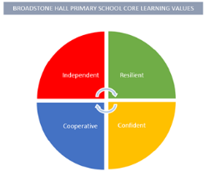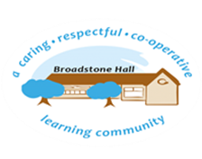

subject overview – Computing in eyfs

Intent

ICT in the EYFS underpins all areas of learning. Children will be exposed to how technology is used in everyday life and ways it can be beneficial to them.

What This Looks Like In An EYFS Environment

In Nursery children have access to an iPad and a large interactive whiteboard. Children are actively encouraged to independently use different programmes on the whiteboard to mark make and draw. Staff model how computers are important for every day life. Children also have access to a domestic role play area which gives them opportunities to role play using technology in the home, as well as using water play in outdoor continuous provision.

Similar to Nursery, in Reception children have access to an iPad and a large interactive whiteboard. On the iPad, children are taught to independently access the camera and use it to take relevant pictures of their work and models indoors and out. Staff regularly model how different technology is used ie how to get the pictures from he iPad to the computer, how to access Google and printing work. On the interactive whiteboard, children are taught early on how to access and change programmes independently depending on what they want to achieve.

Relevant Birth to 5 Statements (no Early Learning Goal as ICT is no longer a statutory requirement)

**Range 4**

* Be able to turn on some equipment
* Use water play to investigate ‘low technology’ such as washing and cleaning, and transporting water from one place to another

**Range 5**

* Know how to operate simple equipment
* Show an interest in the use of iPads and touch screen devices
* Know information can be retrieved from the internet