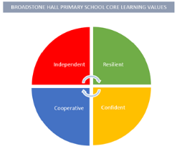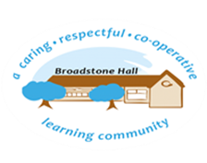

subject overview – Science in eyfs (the natural world)

Relevant Development Matters Statements and Early Learning Goals

**Nursery (3-4 year)**

* Make connections between the features of their family and other families.
* Notice differences between people.
* Continue developing positive attitudes about the differences between people
* Reception

**Reception**

* Understand that some places are special to members of their community.
* Recognise that people have different beliefs and celebrate special times in different ways.

**ELG**

* Know some similarities and differences between different religious and cultural communities in this country

What This Looks Like In An EYFS Environment

In nursery children will have access to different texts and images relating to different religious events. They will be given the opportunity to explore these texts and images, speak to people of different faiths and participate in different celebrations. In reception children will have the opportunity to continue to explore different texts and images as well as visit a place of worship. Reception will have the opportunity to speak to people from different faiths and learn about their religion, as well as talking about their own faith.

Key Experiences

Nursery

* Celebrate religious events e.g. Eid, Christmas and Easter
* Nativity production at Christmas
* Exploring religious artefacts

Reception

* Visits to St Elizabeths church at Christmas and Easter
* Opportunity to celebrate Key religious events
* Religious visitors into school
* Exploring religious artefacts