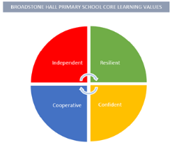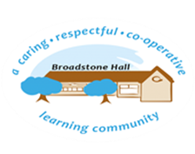

subject overview – PE (Gross motor skills)

Intent

Our children will become confident movers and learn how to use their bodies in a range of ways with increasing control.

What This Looks Like In An EYFS Environment

In Nursery children have continuous access to planks and crates for building and balancing, a climbing frame, bikes and scooters. Through adult supervision and encouragement children have ample opportunities to develop their gross motor skills. As the year progresses children are actively encouraged to put new skills into practice to develop their confidence and independence.

In Reception have weekly PE sessions in collaboration with Primary Sports Coaching. In these sessions children are taught to confidently move in different ways and use a variety of apparatus whilst considering the safety of themselves and others. Children also have access to the large outdoor area with a climbing frame, bikes and building equipment such as tyres, planks and cable reels. Adults encourage children to build, balance and climb whilst developing their resilience and confidence.

Relevant Development Matters Statements and Early Learning Goals

**Nursery (3-4 year)**

* Develop their balancing, riding and ball skills
* Skip, hop and stand on one leg
* Carry larger outdoor items safely

**Reception**

* Refine movement skills such as rolling, crawling, walking, jumping, running, hopping, skipping and climbing and combine these in a sequence
* Develop overall body strength, core strength, co-ordination and ball skills
* Confidently and safely use a range of large and small equipment inside and out

**ELG**

* Negotiate space and obstacles safely, with consideration for themselves and others
* Demonstrate strength, balance and co-ordination when playing
* Move energetically, such as running, jumping, dancing, hopping, skipping and climbing