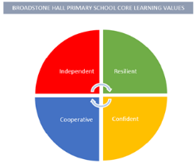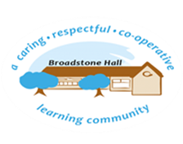

In Geography we aim to inspire a curiosity about the world and its people that will remain with our pupils for the rest of their lives. Our curriculum increases children’s knowledge of different places by exploring carefully chosen locations in depth. We prioritise the critical human and physical processes that are the foundation of Geography, as well as fieldwork. We aim to ensure that our pupils have a secure knowledge of their place the world so that they can make a positive difference in an unknown future.

subject overview - Geography

BHPS Learning Values

Resilience – Opportunities to interpret and review geographical sources and communicate new information.

Independence – Opportunities to explore new places and apply new skills and knowledge as ‘geographers.’

Confidence – Opportunities to build on prior learning, share own experiences and present geographical findings.

Cooperation – Opportunities to work with peers to explore and research, particularly in fieldwork.

Inclusive Practice

Fieldwork, exploration and the use of new vocabulary is key in becoming a knowledgeable and purposeful geographer. The application of these skills allow all children to access and engage with our well-planned curriculum through cooperative, active and research based learning.

Links to Reading

* Map work / signs
* Atlases
* Research articles
* Explanation texts
* New vocabulary
* Biographies
* Non-fiction texts
* Geographical reports
* Looking at data / trends

Long Term Learning

Use of knowledge mats at the start and throughout a unit of work. Use of Cooperative Learning Strategies to explore, discuss, understand and embed the critical knowledge of geography.

Core Threads

* Learning and applying knowledge of the location of globally significant places
* The use of key geographical skills and fieldwork
* Understanding how and why the human and physical features of our world are like they are and how people impact this

Sequence of Learning

In EYFS children are exposed to their immediate and local environment and encouraged to explore it, through ‘Weekly Wanders’ and other planned activities. In Key Stage One, children further explore their local environment and place knowledge through fieldwork, map work, comparing and contrasting localities and extending their geographical vocabulary. In Key Stage Two, this is built on by extending the environments and places they explore in depth, to enhance their locational and place knowledge and significant human and physical features.