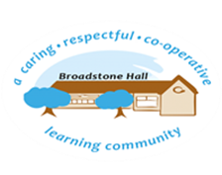

In French, we want our children to develop a love of learning languages and to have a secure knowledge and understanding so that children are confident to use French both orally (for speaking and listening) and in early reading and writing. At Broadstone Hall, we want children to develop language learning skills which can be applied to learning other new languages and to develop curiosity about different cultures.

subject overview - FRENCH

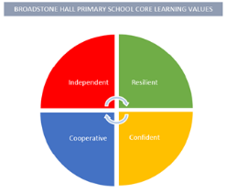

Inclusive Practice

The emphasis in French is on speaking and listening in the first place, which lends itself to an equitable teaching and learning experience. New content is always introduced by means of songs, games and practical activities which means all children can access it. Reading and writing is scaffolded so that all can succeed.

Links to Reading

* Authentic French children’s books-hard copies and flipchart versions
* Recipes
* Information texts
* Lyrics of French songs
* Bilingual dictionaries
* Menus

Long Term Learning

All lessons are taught by either a specialist teacher or class teachers with appropriate expertise. Frequent repetition of previous language especially through songs and Can I still?

Core Threads

1. Speaking and listening.
2. Reading and writing.
3. Language learning skills.
4. Understanding of the world including intercultural awareness.

BHPS Learning Values

Resilience – Opportunities to ‘have a go’; it is a new language for all so misconceptions are normal!

Independence – Opportunities to develop and share own language learning strategies and to ask questions about cultural traditions and practices as well as the French language.

Confidence – Opportunities to speak aloud individually and as part of a group, to share ideas and articulate opinions clearly.

Cooperation – Opportunities to work collaboratively with peers to carry out conversations, role plays and games.

Sequence of Learning

Children start their French learning in year 3, and in Lower Key Stage 2 the focus is on speaking, singing and listening, with whole class shared reading of authentic French texts and some simple writing activities. The children begin to learn about phonics and are introduced to using a bilingual dictionary. In Upper Key Stage 2 children are encouraged to speak, understand, read and write more complex sentences, using a dictionary independently. Longer and more complex authentic French texts are used for reading and features of grammar are taught more explicitly.