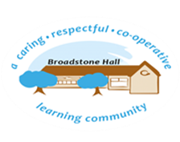

In Design and technology, we aim to inspire a generation of makers, engineers and architects. By building on children’s individual strengths and developing their resilience, children will become resourceful and confident in their own design process. At Broadstone Hall, we want children to think creatively and have the knowledge to develop their technical and practical skills with the understanding of the significant impact Design and Technology has on their daily lives and the world around them.

subject overview -Design TECHNOLOGY

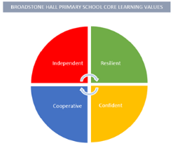

Links to Reading

* Instructional texts
* Research articles
* Biographies of inventors and designers
* Fiction books about inventors
* Design floorplans and documents

Long Term Learning

Knowledge mats, practical experiences and real-life applications will support long-term learning.

Inclusive Practice

The nature of Design Technology is innately practical. This allows children of all abilities the opportunity to use their imagination and creativity to create something unique.

Children can draw on their strengths from other subjects to solve problems, ask questions and become resourceful citizens of the future.

Core Threads

1. Developing creative, technical and practical expertise.
2. Build on prior knowledge, key vocabulary, understanding and skills to design, create and evaluate a product for a purpose.
3. Develop an understanding of the critical impact of Design Technology in their daily lives and on the world around them

BHPS Learning Values

Resilience – Opportunities to learn new skills and build on the strengths of the child as an individual

Independence –. Opportunities to work independently to design, evaluate and make products for a purpose.

Confidence – Opportunities to build on prior knowledge, ask questions and foster children’s confidence in their own ideas and abilities.

Cooperation – Opportunities to work collaboratively with peers when evaluating and making products

Sequence of Learning

In EYFS, continuous provision used to encourage children to develop their imagination and creativity. They explore different materials and textures. Children learn through modelled play and are taught to design and build for a purpose. Children are taught to work collaboratively and discuss what they have learnt and created. This is built on throughout Key Stage One and Two, through real-life applications and study of successful designs.